**Optimization (Placement Editing)**

**Problem Statement:**

In current version of Nexelus, optimization module only work based on existing media plan(s) and it doesn’t allow editing at the placement level as well. However, most of client interested in functionality which will allow them to create media plan and edit individual placements as well.  
  
**Proposed Process:**

To address this request from clients, Nexelus will introduce new feature in optimization module which will allow users to create new media plans from optimization UI and will also allow users to edit placement level details for media plan(s) from this UI.  
  
**Proposed Changes:**  
  
Following User interfaces will be changed to address this request.  
  
**Main UI:**currently, optimization UI only allows to select existing media plan(s). however, based on user request, Nexelus will add an option to create new median plan from Main UI of interface by adding another action button “+ Media Plan”.

This option will allow users to create new media plan. User must select campaign before creating new media plan. if user clicks on this button and campaign is not selected, system will prompt user to select campaign first.

System will work as following once user clicks on this action button.

1. Once user clicks on this action button, system will preserve current state of UI (all plans load, optimization criteria and/or any changes made by user so far) and will redirect user to media plan UI in “New Media Plan” mode with campaign pre-selected on media plan. however, “Campaign Lookup” will not be available on media plan UI in this case to restrict user to create media plan only for selected campaign.
2. Another action button “Go Back” (it will be visible only if user is coming from optimization UI) will be added in media plan UI which will allow user to come back to UI. Once user creates the media plan and clicks “GO back” button, system will take user back to Optimization UI and re-load all preserved data in step 1 and add newly created Plan in UI as well.
3. Graphical user interface, text, application

   Description automatically generated

**Detail UI:**

Following changes will be implemented on Detail UI to allow users to edit placement level details for individual media plan.  
  
**Placement View Option for specific Month:**  
  
New image button “View / Edit Placement(s)” for each month cell will be added in the grid. Once user clicks on this button for specific cell, system will display all placement(s) for specific month in placement view. (Remember, once placement can contribute to multiple months, system will display all placements which are adding up in amount for specific cell / Month.).   
Placement View will allow user to Add / Edit Placement directly from this UI.

**Placement View**this view will replace Optimization details view with placement view. placement view will display all placements which are adding up into months spend. And if user has clicked on cell from optimization rule row, system will display updated placement(s) based on optimization rule selected for the row.

Placement view will have Grand totals section visible as well which will get updated on runtime once user changes any value for any placement

User can add / Edit and /or Delete placements from this view.

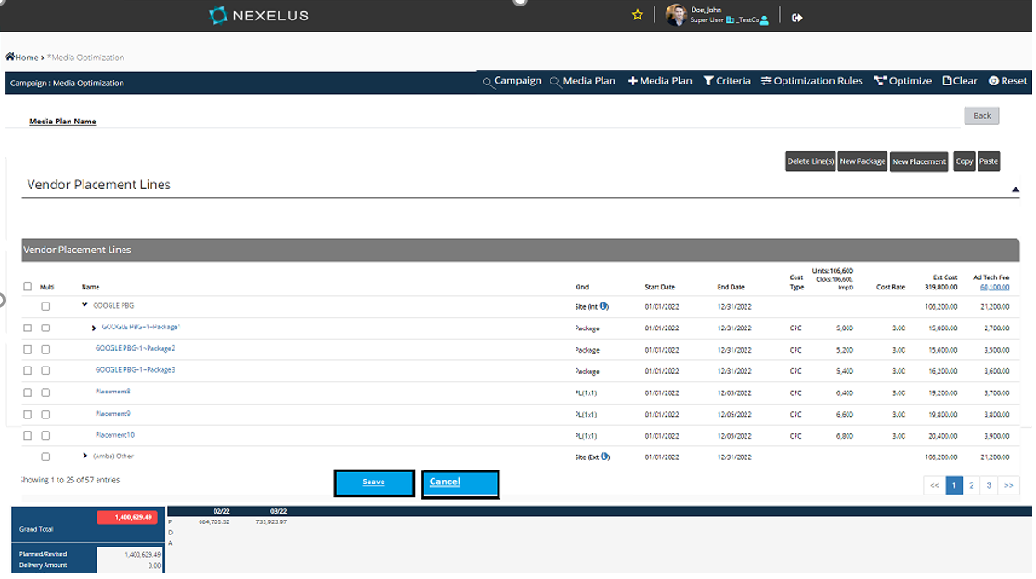

Placement section will work the same way it is working on media plan user interface. However, this section will have fewer options than media plan user interface.

User can perform only following actions from this UI.

1. Add Placement / Package.
2. Delete Placement /Package
3. Copy / Paste Placement / Package.
4. Import / Export Placements.
   1. Import / Export will not be available if user is viewing placements for specific months by clicking on icon next to each month.
5. Ads and creative features will not be available from this UI.

This UI will have 3 action buttons.

1. Go Back.
   1. This action button will take user back to optimization detail UI. If there are any un-cased data on UI, system will prompt user to save or reset changes before action.
2. Save:
   1. This action button will save all changes made by user. And will take user back to optimization detail UI.   
      If user came to this placement View UI from Planned “P” row, system will create new Row and will tag it as manual editing and will update months data based on new changes. Furthermore, system will change color of placement icon for month cell which user has edited.  
      if user came to Placement view UI from any optimization Rule line, system would change status of that line to manual edited line, update month’s data based on user’s changes and will change color of “Placement view Icon” to visually indicate the month which was changed manually.
3. Cancel:
   1. Cancel will take user back to placement UI without any change if there is no change on UI. If there is a change on UI, system will ask user to save or reset before current action.
4. Reset:
   1. Reset will reset any changes made by user on this view.

**Edit Media Plan Option:**

This option will allow users to view all placements for specific media plan. once user clicks on Edit button next to each media plan, system will display “**Placement View UI**”**.** However, with this option user will display all placements across all vendors for specific media plan.

An addition action button “Add Vendor / Site” will be added in “Placement View UI” which will allow users to add new Site in media Plan.

System will open Vendor / Site lookup (same lookup we are displaying on media plan UI as shown below) once user clicks on add vendor / site action button.

**Vendor Site Lookup**

This lookup will allow users to add new site with to media plan. User can also add new or update existing site mapping from this UI the same way we are allowing it from media plan  
clicking on add new mapping will display new mapping UI.

**New Mapping UI**

Remember, Nexelus allows to add unmapped sites to media plan as well (please refer to media plan UI for clarification). The same feature will also be available from optimization UI which will allow users to add unmapped sites to media plan.  
  
This view will allow Import / Export placements as well.  
Once user clicks on save button, system will save the changes and add new optimization Line in UI.  
  
Note – Open Item: How editing and re-editing will work, will it be based on original revision or based on updated change user has made, we will discuss this point later.   
  
**Change in Approval Process**   
as we are allowing users to add unmapped sites, We will need an addition check during multiple authorization process to check if there is any unmapped sites in any of selected media plan(s) and if there is any unmapped sites, system will throw an error that there are unmapped sites mapped sites before approval (please use the same message, we are displaying on media plan).

**Navigate to Media Plan option:**

We will provide user an option to navigate to media plan as well by clicking on media plan name. clicking on media plan name will navigate user to Media plan UI, where user can view media plan and/or make changes and come back to Optimization UI.  
Once user clicks media Plan name, System will prompt to user as “This Action will redirect to Media Plan User Interface, please press ok to continue.”.­­­ once user clicks on OK button, system will preserve current state of optimization UI and will redirect user to Media plan UI with selected media plan loaded on UI. User can make any change on media plan and once user is done with changes. user can go back to optimization UI using “GO Back” button.  
clicking on Go Back button will redirect user back to optimization UI, system will restore Optimization UI based on preserve state and will update optimization data based on changes made by user.

Please note that user can make any change on Media Plan UI. i.e. Adding vendor, removing vendor, Adding / removing placements, changing dates etc. once user comes back to optimization UI, system should adjust optimization UI data based on new changes.

**Question**: If user has already applied optimization rules based on OLD data. how system will work as optimization rules applied based on OLD data may not be valid anymore.  
**Answer:** Simple solution to this is to restrict user from editing media plan if any of optimization rule has been applied on UI for specific media plan.  
**Question:** Currently, we are loading approved / latest revision of media plan base on rule. with this change we would have to load latest revision always if user updated media plan.